About the Company
Welcome to BioSurgica, where healthcare meets trust and innovation. Establish by a seasoned Pharmacist and a dedicated Medical Doctor, our leadership brings over 16 years of experience in the healthcare and medical supply industry.

Our journey
Our story began decades ago when the founders embarked on a trading venture under the name Faisal Brothers, National survey Engineering LLC and Matrix Laboratory L.L.C. Driven by dedication, passion, and an unwavering work ethic, they laid the foundation of a legacy that was more than just business — it was their calling.
At one point, Faisal Brothers proudly stood as the sole supplier of fabric for armed forces uniforms and hospital supplies, marking a significant milestone in our early success.
Matrix Laboratory is accredited with ISO/IEC 17025 as well as ISO 9001, ISO 14001 & OHSAS 18001 Matrix is a group of engineers and technical professionals committed to provide the best class in engineering solutions meeting the international standards.
National Survey Engineering a surveying firm established in April 2004 in Dubai. Worked with reputed Consultants, Architects, Contractors, Government and Semi-Government organizations.
Our goal is to emerge as a market leader by consistently exceeding customer expectations with exceptional products and services, while positively contributing to the communities we serve.

Introduction
In today’s competitive marketplace, consumers increasingly expect higher quality and cost-effective solutions, creating significant challenges for modern entrepreneurs. We are proud to introduce Biosurgica, one of Pakistan’s most advanced Biological and Surgical equipment providers. We are specialized in providing high-quality biologicals, Vaccines and surgical disposable items, designed to meet the evolving needs of modern medical professionals.
Our company legacy is built on a strong foundation of quality standards setup by National and international regulators.
OUR FIELD:
- AUTO-IMMUNE DIASEASES
- VACCINES
- INNOVATIVE SURGICAL PRODUCTS

AUTO-IMMUNE DIASEASES:
Inflammation is a biological response to potential danger or damage to organs in our body. But with autoimmune diseases such as rheumatoid arthritis, ulcerative colitis, Psoriasis and many others, our own immune system becomes dysregulated and turns against our organs.
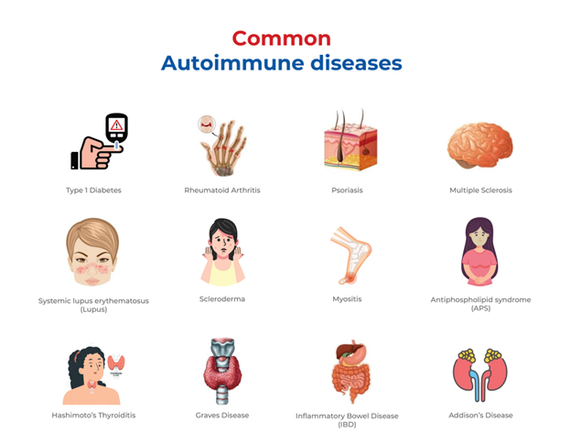
Our mission is to make cutting-edge biological therapies, immunoglobulins, and the most advanced available medicines accessible and affordable to every patient in need, while upholding the highest standards of quality, compliance, and clinical excellence for all stakeholders — including healthcare professionals, regulatory bodies, and our partners."
VACCINES:
"With a core focus on improving healthcare for every individual, our journey began at the very start of life — by providing comprehensive immunization solutions from birth as a trusted manufacturer of high-quality vaccines."


INNOVATIVE SURGICAL PRODUCTS:
To thrive in a rapidly advancing world, innovation is not optional — it’s essential. We are committed to delivering world-class medical devices and surgical products, such as our auto-injector syringe, that support modern healthcare systems and improve lives across the globe.
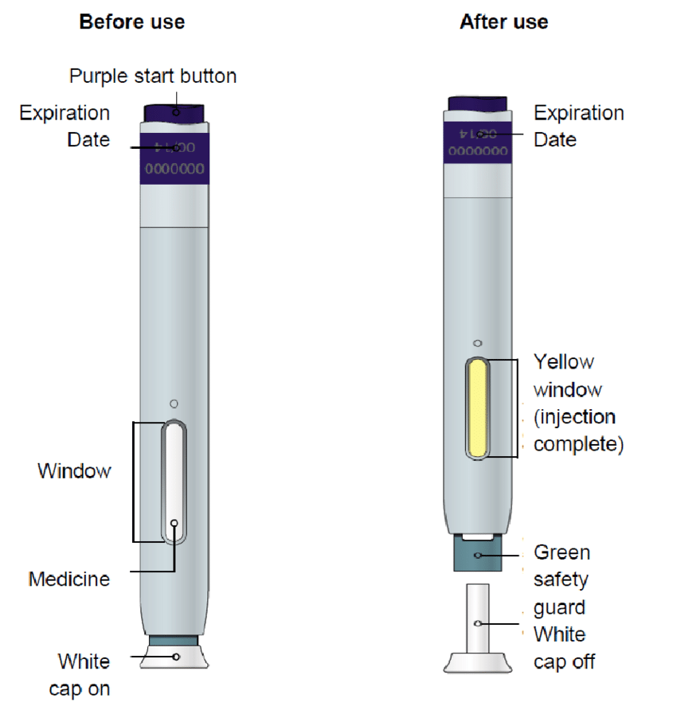

REGITRATION AND ASSOCIATIONS:
- DRAP
- ISLAMABAD CHAMBER OF COMMERCE AND INDUSTRY
- DUNS& BRADSTREET
- CPHI & PMEC
- EPADS

Social Welfare:
As part of our long-standing commitment to corporate social responsibility, we have been actively supporting individuals with disabilities through the Pearl Welfare Organization for over two decades. We believe that true empowerment comes not from charity, but from opportunity. Our initiatives focus on enabling self-reliance, dignity, and inclusion — helping those who were once dependent become confident, contributing members of society.
Mission:
At Biosurgica, we are driven by a single purpose, necessity within reach. We are committed to delivering high-quality biological and surgical supplies where they are needed most reliably, efficiently, and ethically. By bridging the gap between innovation and accessibility, we aim to support better patient outcomes and empower healthcare providers across all levels of care.
Vision:
At Biosurgica, we are dedicated to advancing the next generation of therapies for patients facing the most serious health challenges — with a relentless focus on maximizing every opportunity for success
Ethos:
We are committed to advancing healthcare by delivering safe, reliable, and innovative biological and surgical solutions. Our team continuously evolves with new scientific standards to ensure that healthcare professionals receive products they can depend on.
We believe in building long-term relationships and contributing positively to the healthcare community through responsible, sustainable, and people-focused practices.
Company Network:
Our company is dedicated to providing innovative solutions that are crucial for addressing the ongoing healthcare challenges of Pakistan. To achieve this goal, we have assembled a team of skilled and experienced professionals across Distribution, sales, and marketing.
Head Office:
Plot # 386, Street # 16, I-9/3 Industrial Area, Islamabad
Phone: +92-331-8884811
Email: info@biosurgica.com
Website: www.biosurgca.com

Product Range:
- Syringes
- Anesthesia
- Biologicals
- Vaccines
Syringes:
- IV Luer Lock Auto Disable Syringes
- 1cc
- 3cc
- 5cc
- 10cc
- Oral Syringes
- 1cc
- 3cc
- 5cc
- 10 cc
- 20cc
- 50cc
- 60cc
- Insulin Syringes

- Pre-filled Syringe
- Pre filled syringe
- Pre filled auto injector Syringe
2. Anesthesia
- Oxygen Mask
- Nebulizer Mask
- ETT cuffed/uncuffed
- NG tube
- Silicone and PVC Resuscitator
- Nasopharyngeal tube
- Stomach tube
- Suction Catheter
3. Biologicals
- Anti D (Rh-D immune globulin)
- Secukinumab
4.Vaccines
- Purified tetanus toxoid
Valued Customers:
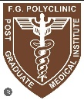

Corporate Partners:

